
Peripheral Venepuncture
Using Standard-ANTT in a Community Care setting
for the ANTT Practice Framework see: www.antt.org

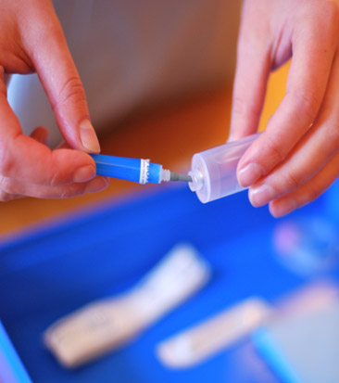
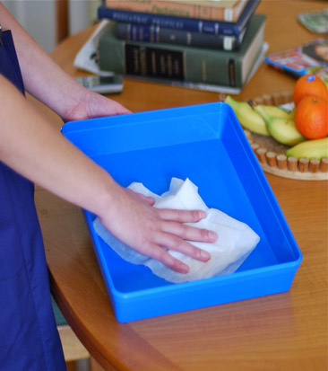
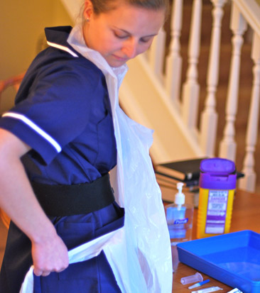
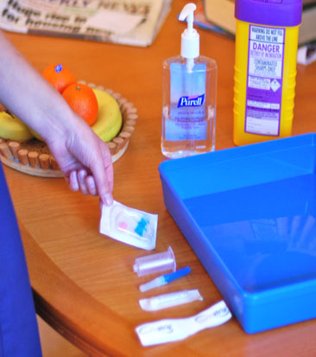
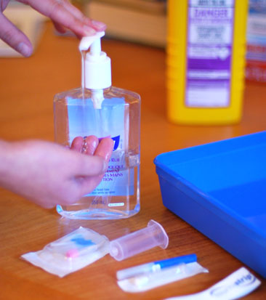
5
4
3
2
1

4
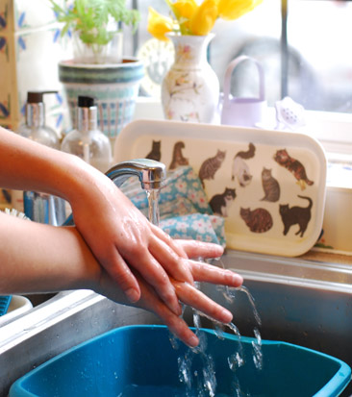
When entering the patient’s home
disinfect hands

Gather Equipment
& place around tray

Prepare Equipment
protecting Key-Parts with non-touch technique (NTT) & Micro Critical Aseptic Fields

Disinfect Hands
with alcohol hand rub
or soap & water

Disinfect Tray
as local policy – creating
a General Aseptic Field

Apply Disposable Apron

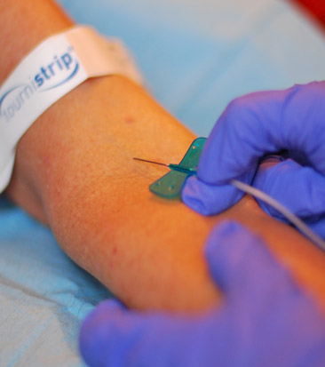
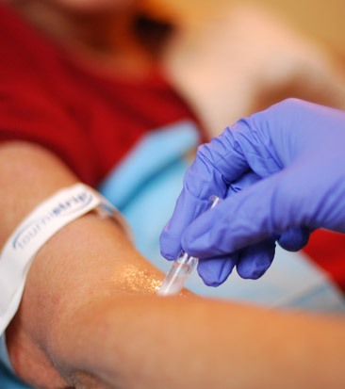
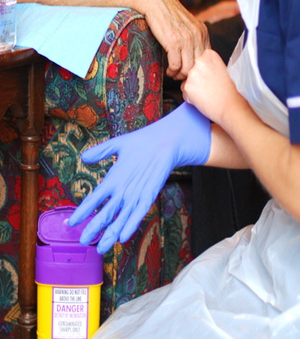
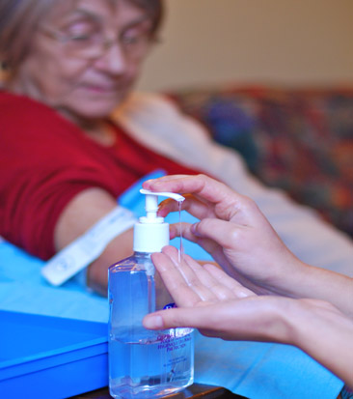
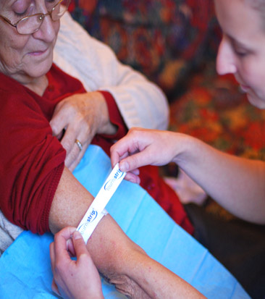
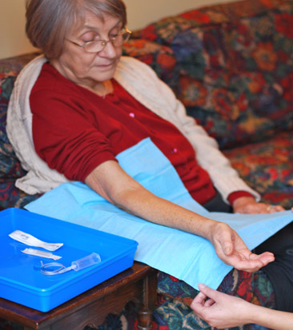
11
6
9
7
10
8

If attempt to
draw blood is unsuccessful
return
to step


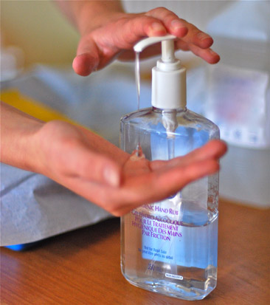

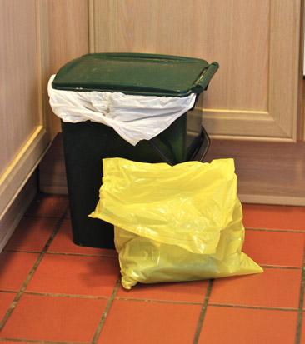
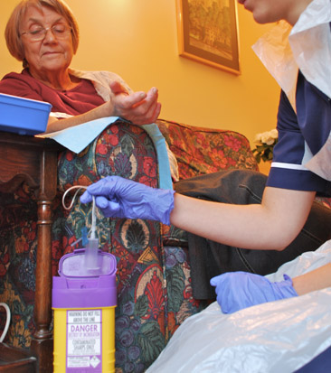
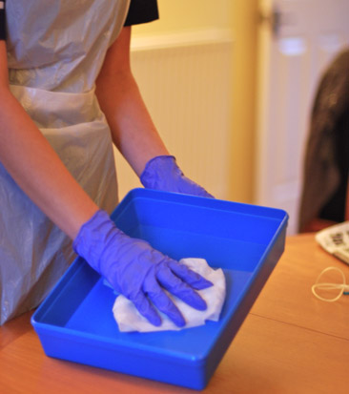
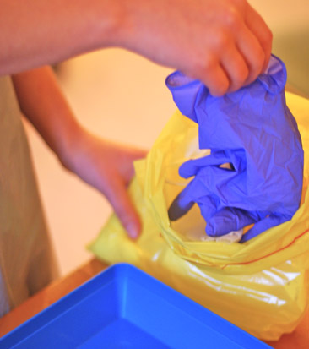
Apply Tourniquet
(use single-use disposable tourniquet) palpate
vein & release tourniquet

Disinfect Skin
with a 2% CHG / 70% IPA
using friction for 30 seconds.
Allow to dry

Place Drape
under the patient’s arm

Access Vein
protecting Key-Parts &
Key-Sites using NTT

If re-palpation needed, repeat step 10 or use sterile gloves*
Apply Gloves
(use sterile gloves if Key-Site must be touched directly)*
& re-apply tourniquet

Disinfect Hands
with alcohol hand rub
or soap & water

12
15
16
7
Dispose of Sharps
and equipment

Disinfect Hands
with alcohol hand rub
or soap & water

Dispose of Waste
according to local policy

When leaving the patient’s home
disinfect hands

Dispose of Gloves
then apron & immediately…

Disinfect Tray
according to local
policy

13
14
ANTT® © v4.0 Please note that local policy or equipment changes may be applied. For advice, please see enquiries@antt.org

