

Patient zone
Simple Wound Care for the ANTT Practice Framework see: www.antt.org
Using Standard-ANTT in a Community/Home Care setting

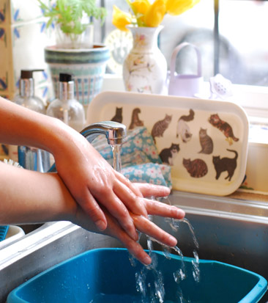
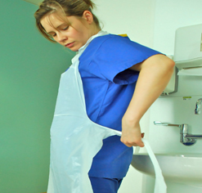
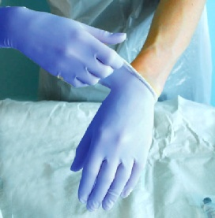
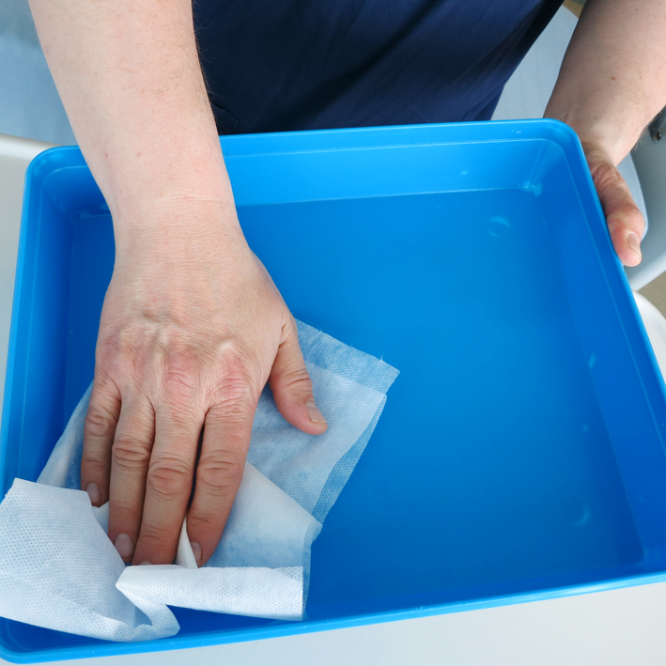
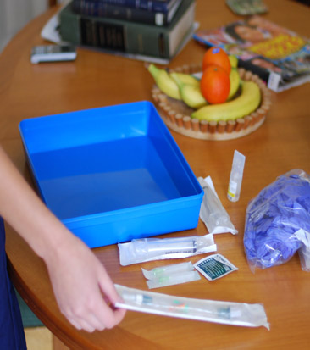

Preparation zone
3
4
2
1
Dispose of Dressing
Apply Non- Sterile Gloves
as per local policy

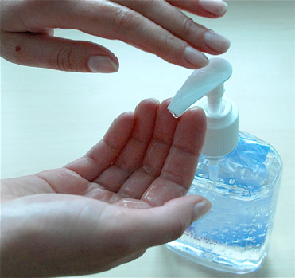

When entering the patient’s home
disinfect hands

Apply Disposable Apron & disinfect hands

Gather Equipment
& place around tray
Disinfect Tray
according to local policy creating a General Aseptic Field

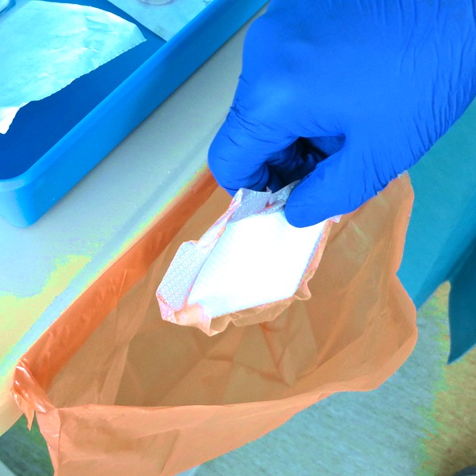
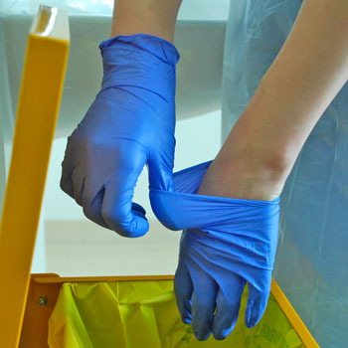
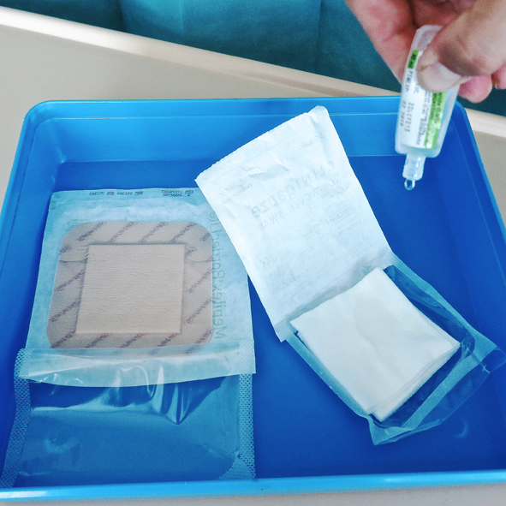
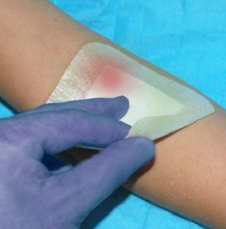
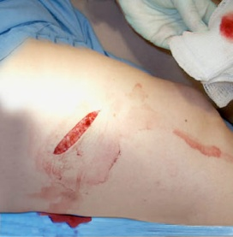
9
6
8
11
7
10
5


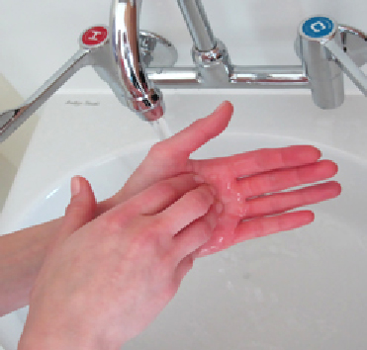
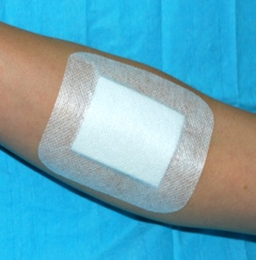
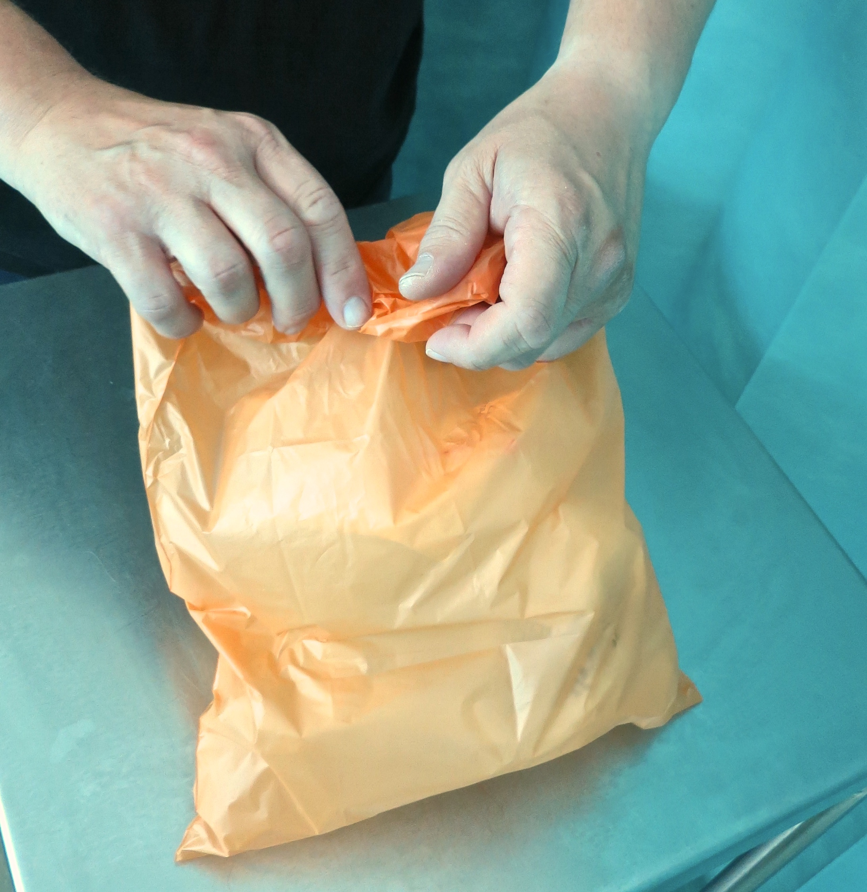

Dispose of Gloves
& immediately …
13
12
15
15
1618
Disinfect Hands
with alcohol hand rub
or soap & water

Remove Dressing protecting Key-Site with non-touch technique (NTT)

Apply New Gloves
as local policy & assemble equipment using NTT
Disinfect Hands
with alcohol hand rub
or soap & water

Dress Wound using NTT

Dispose of Waste
& equipment, gloves then apron & immediately…

Disinfect Tray
according to local policy

Disinfect Hands
with alcohol hand rub
or soap & water

Open Equipment
protecting Key-Parts with NTT & Micro Critical Aseptic Fields

Decontamination Zone
Clean Wound protecting Key-Site using NTT

ANTT® © v4.0 Please note that local policy or equipment changes may be applied. For advice, please see enquiries@antt.org

