Prescribing Update: Fluorouracil 5FU (formerly Efudix) 5% Cream Primary Care
Lancashire and South Cumbria Medicines Management Group (LSCMMG) has approved the prescribing of Fluorouracil (Efudix) Cream within Primary Care for the management of Actinic Keratosis and Bowen’s Disease. This decision was formally ratified in February 2023 and supports improved access to effective topical treatments for patients with sun‑damaged skin lesions.
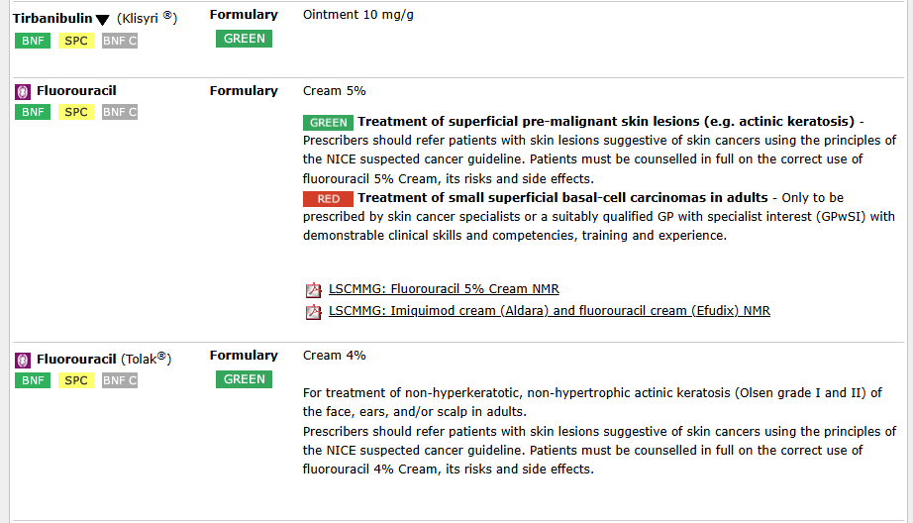
Fluorouracil 5% Cream – Indications and Use
Fluorouracil is a topical preparation used to selectively target atypical and sun‑damaged keratinocytes. It is indicated for:
• Actinic Keratosis (AK)
• Bowen’s Disease
Fluorouracil (also known as 5FU) works by destroying dysplastic skin cells while leaving healthy skin largely unaffected. This makes it a valuable option for managing lesions where early treatment can reduce progression to invasive disease.

Alternative Options: Tirbanibulin (Klisyri) Ointment
In the event of Fluorouracil supply issues, an approved alternative—Tirbanibulin (Klisyri) Ointment—can also be prescribed in Primary Care for Actinic Keratosis. Tirbanibulin is a newer topical agent used over a short course and may be considered when Efudix is unavailable or unsuitable.
Further Guidance
Full prescribing information, formulary status, and clinical guidance can be found on the Lancashire and South Cumbria Formulary.
Education and Support
The below QR code provides access to a suite of dermatology educational videos produced by the Lancashire & South Cumbria Cancer Alliance. These include a dedicated resource on identifying Actinic Keratosis, supporting timely recognition and appropriate treatment in Primary Care.


